### PRACTICAL 9

**AIM:**Practical of Time-series forecasting **STEP 1:** Install timeseries #install.packages(“timeSeries”)

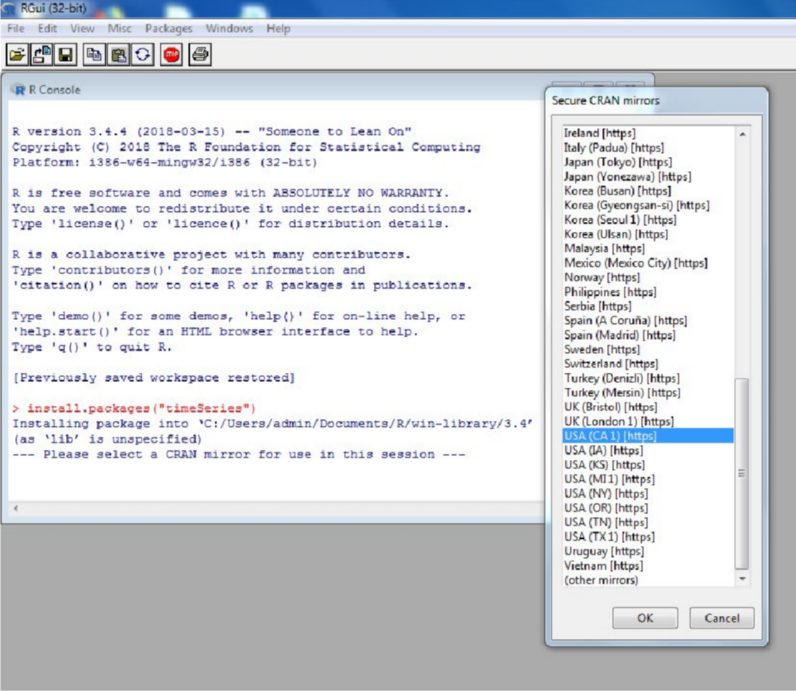

**Step 2:** Install package forecast

**#**install.packages(“forecast”)

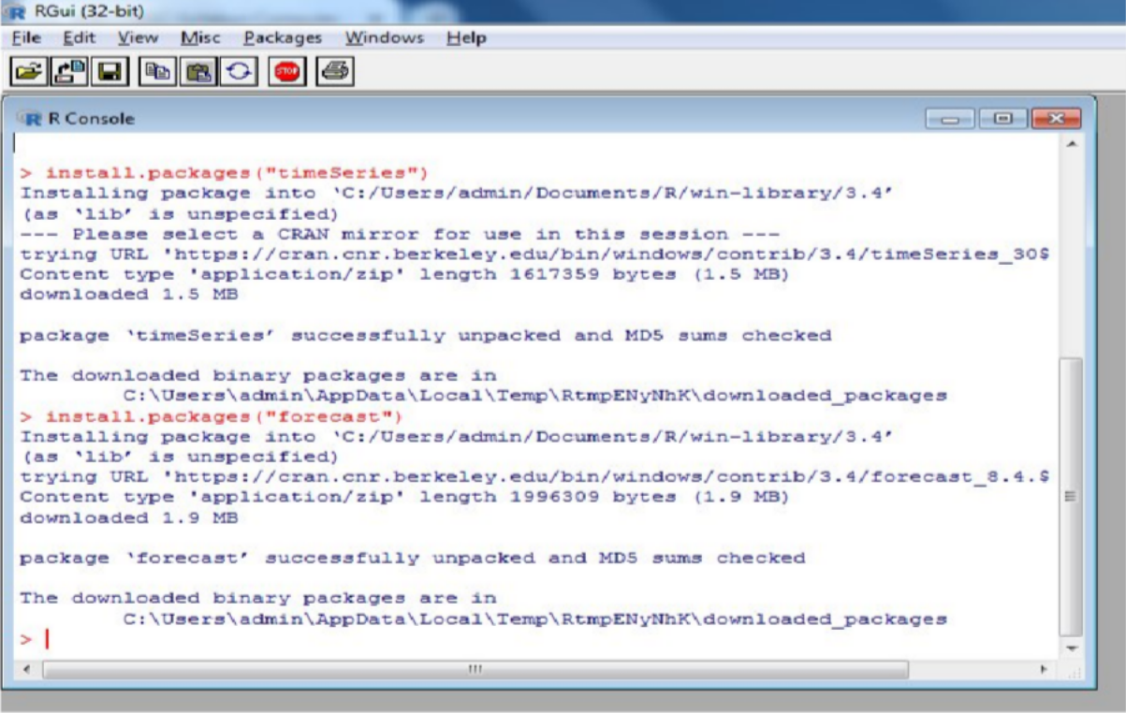

**Step 3:** library (timeSeries) #library(forecast)

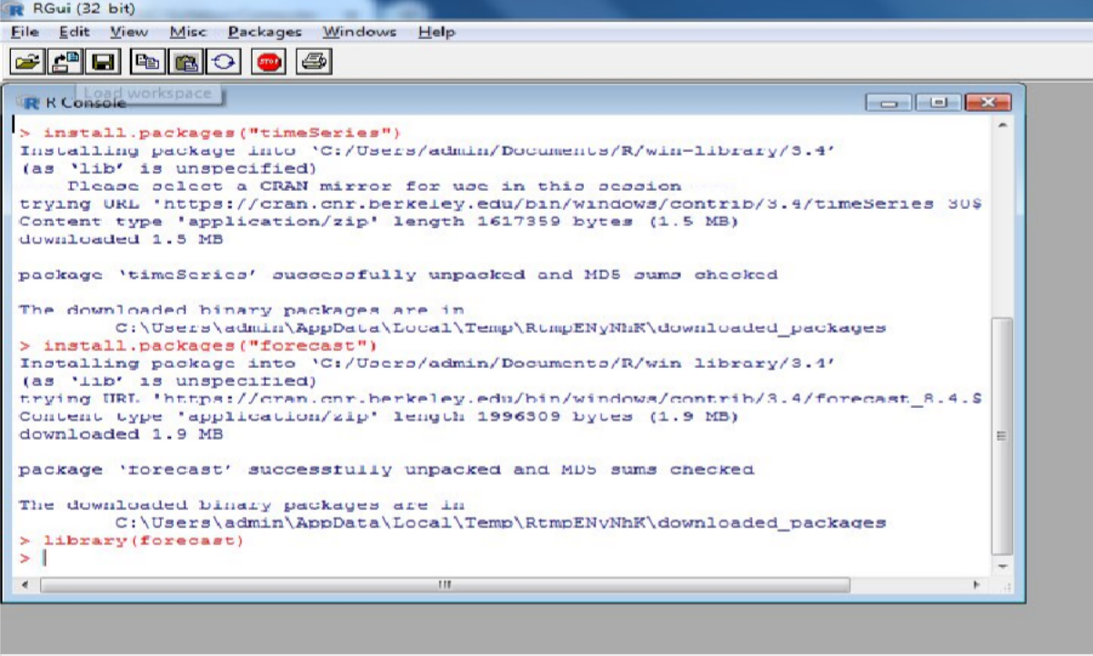

Step 4: library forecast

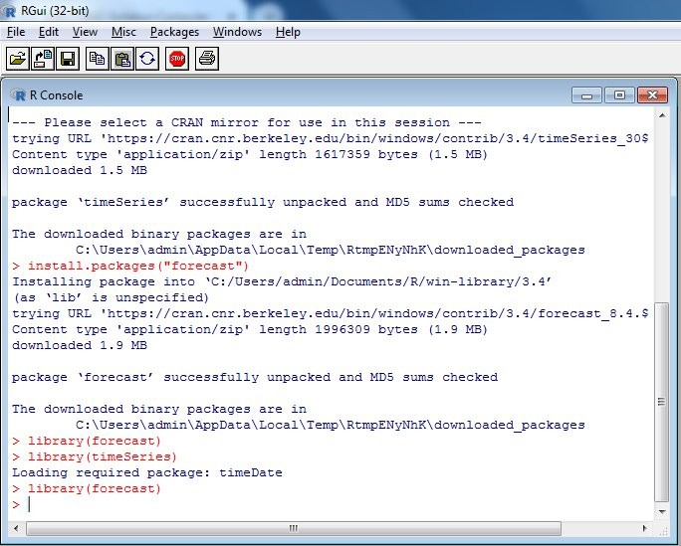

Step 5: Air Passengers data #data1=table(AirPassengers)

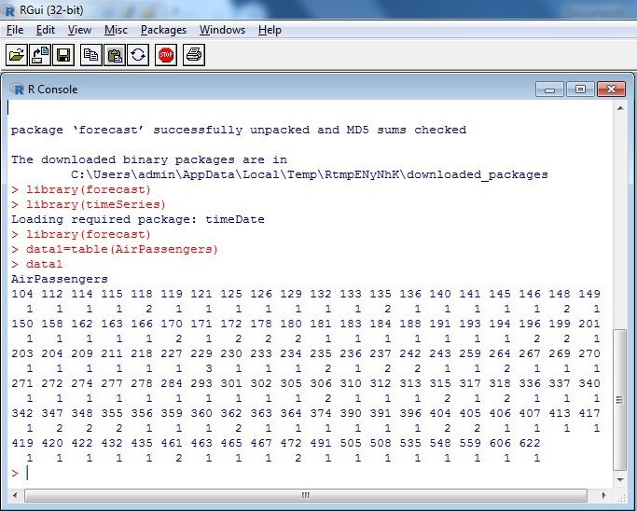

#View (data1)

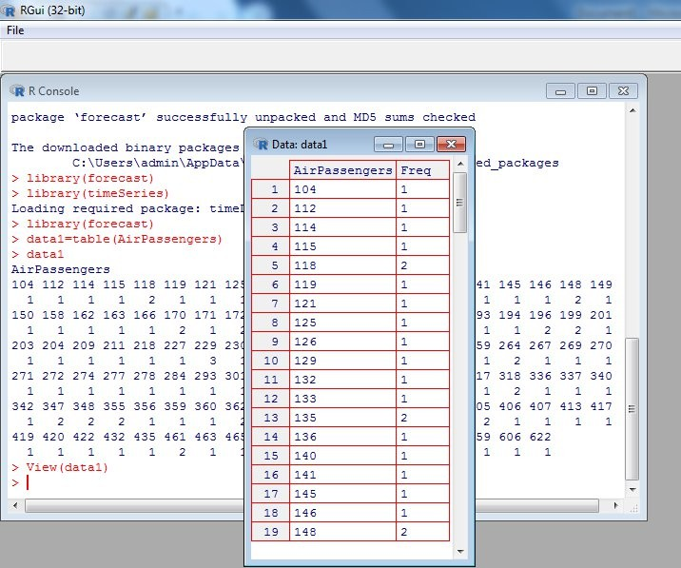

#frequency (AirPassengers)

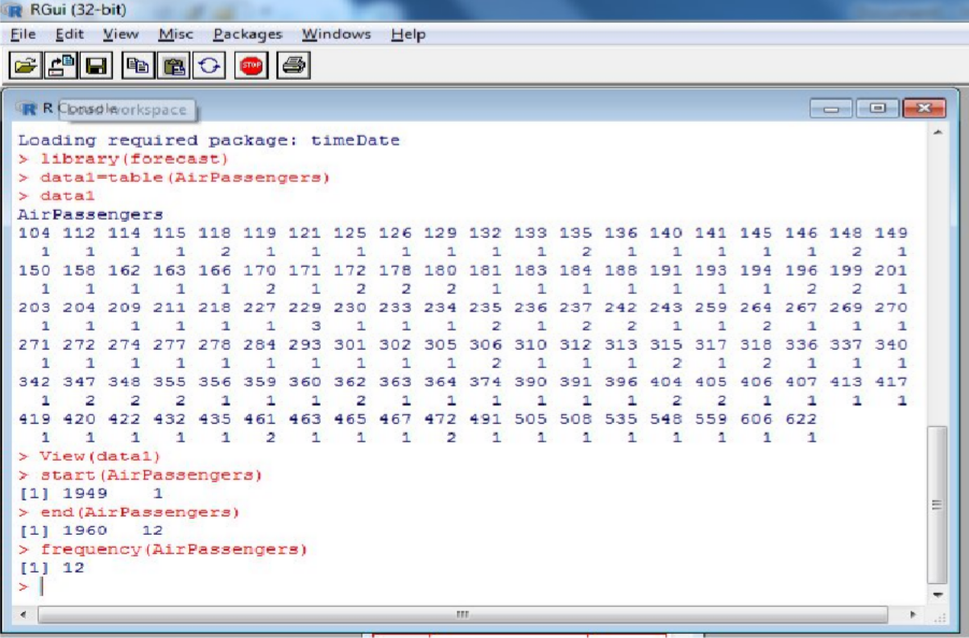

#tsdata=ts(AirPassengers,frequency=12) #tsdata

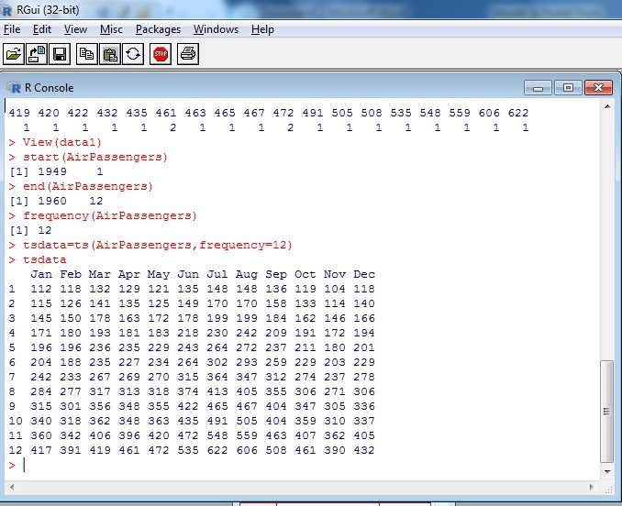

Ploting dataset into random, session, trend, and observed from.

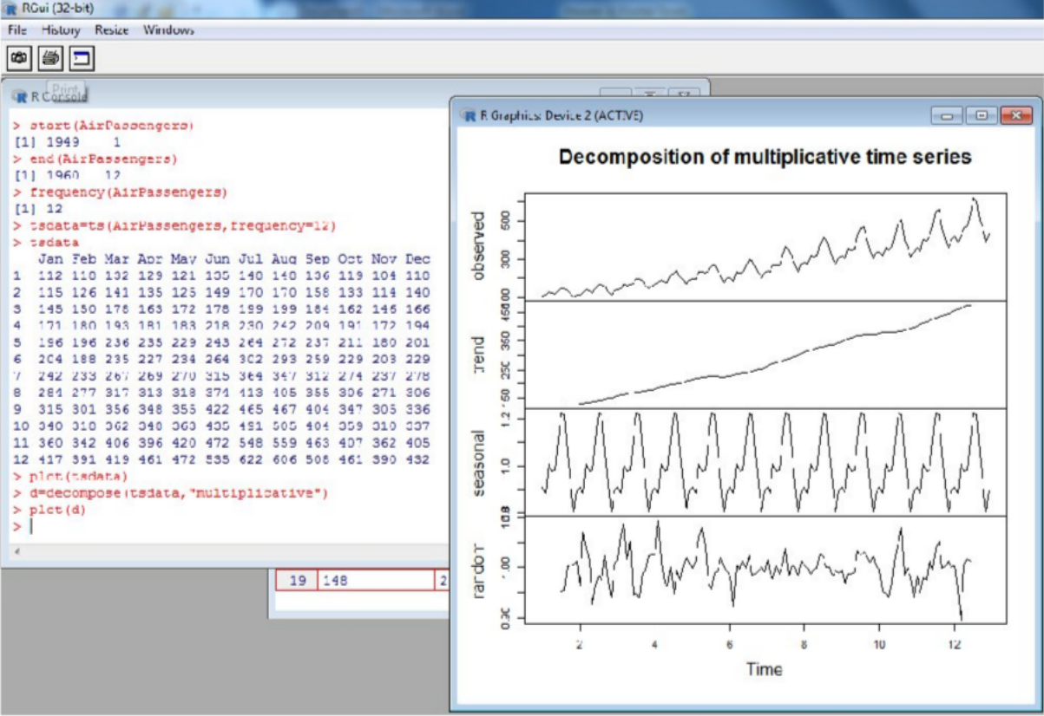

*trend from of data

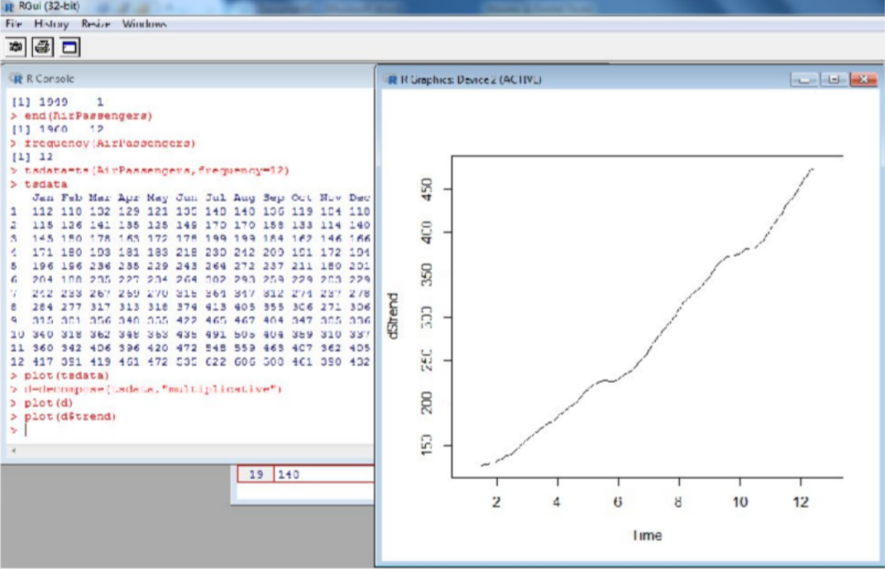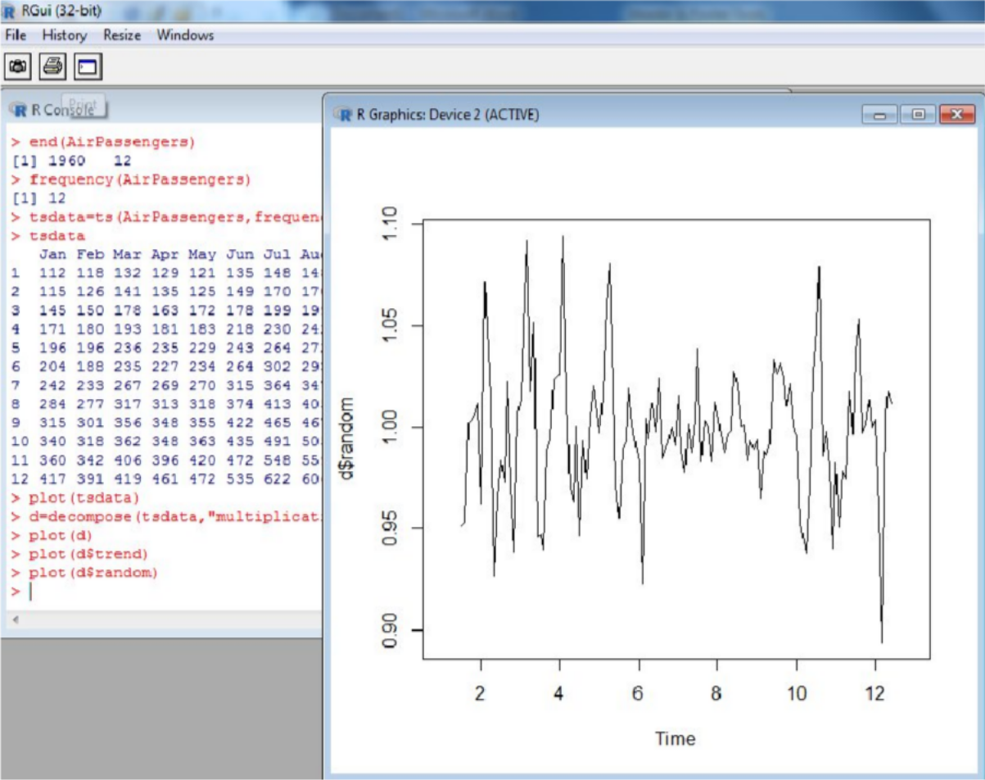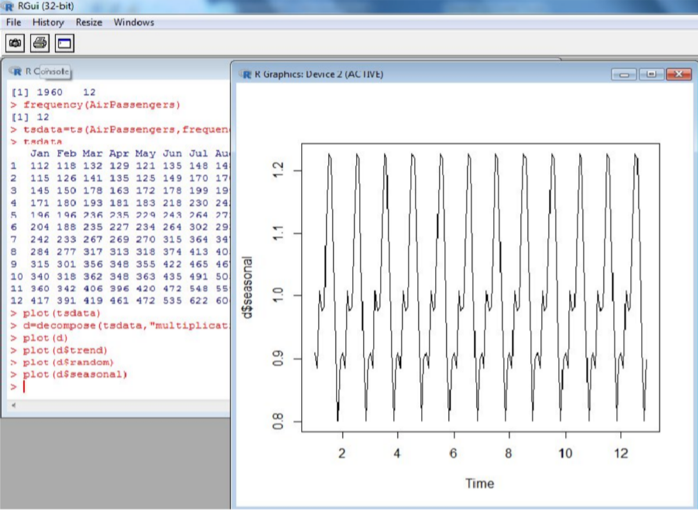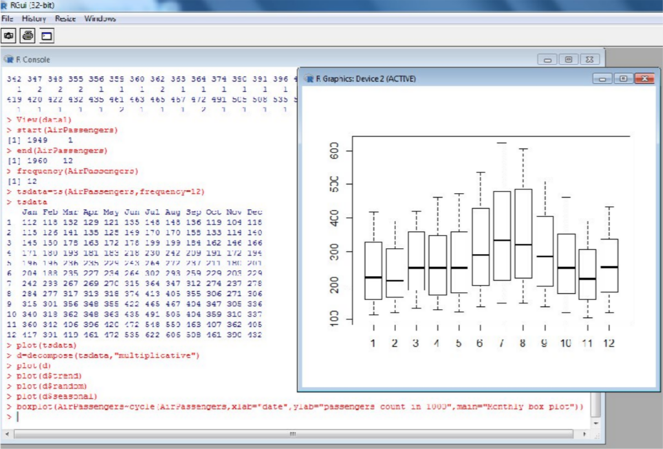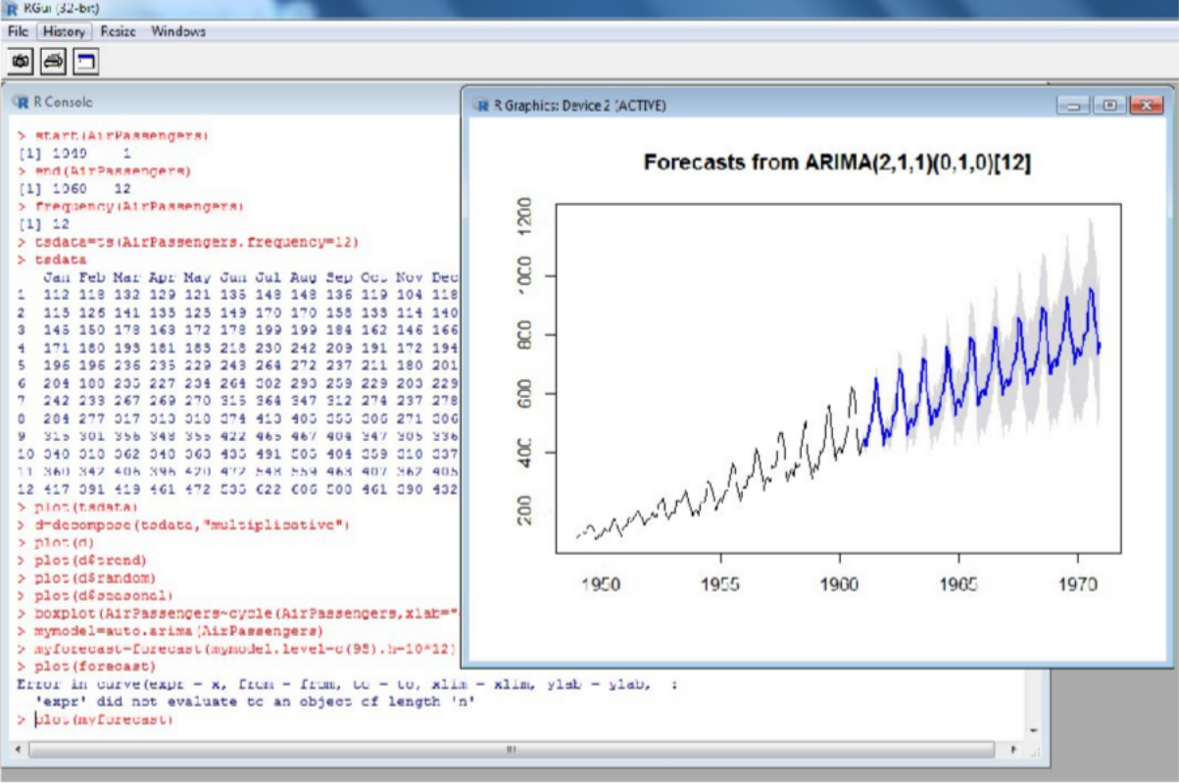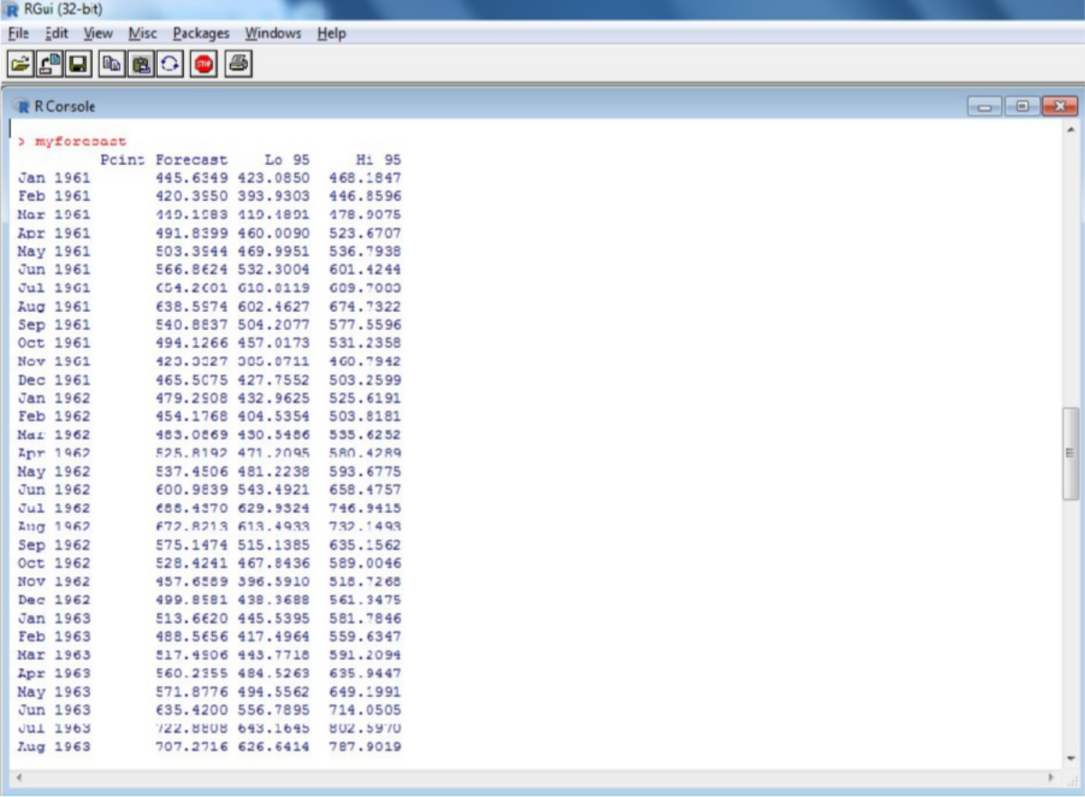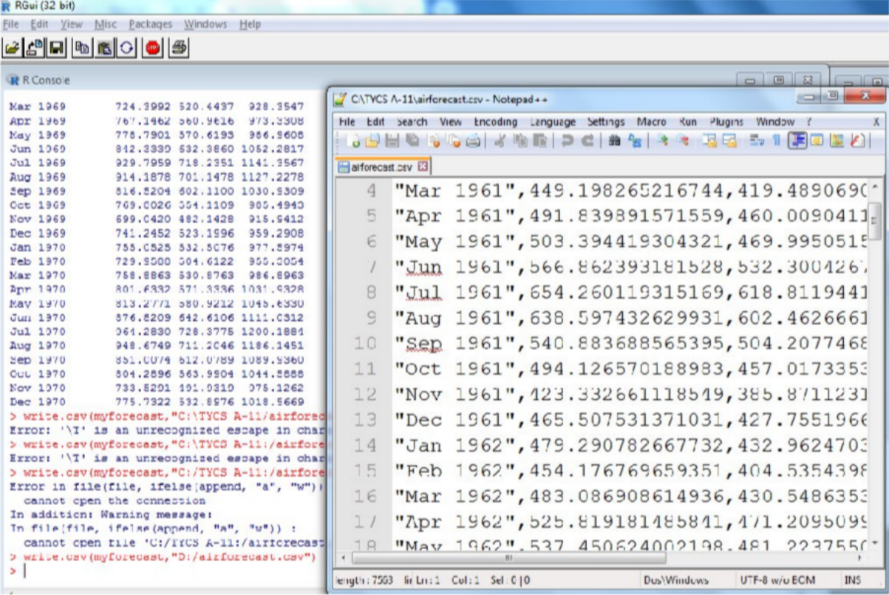

**CONCLUSION:**Thus we have implemented Time Series Forecast successfully.